|  |  |  |
| --- | --- | --- |
| Web Design. | March 14  2016 | |
| **Design and Build a database** | | Assessment |

Peter Petersen – 4101833111  
17 Indigo Crescent - Annandale  
Townsville 4814.  
Mobile-0451919894

**ICADB412A & ICADBS502A**

|  |  |  |  |  |  |  |  |  |  |
| --- | --- | --- | --- | --- | --- | --- | --- | --- | --- |
| **Student Name:** | | | Peter Petersen | | | **Student Number:** | | | 4101833111 |
| **Unit Code/s & Name/s:** | | | **ICADB412A & ICADBS502A - Design and Build a Database** | | | | | | |
| **Assessment Type:** | | | **Exam/Test  Assignment  Other** | | | | | | |
| **Assessment Description:** | | | **P1 – Design and Build a Database** | | | | | | |
| **Assessment Due Date:** | | |  | | **Assessment Received Date:** | | |  | |
| **Student Declaration:** I declare that this assessment is my own work. Any ideas and comments made by other people have been acknowledged as references. I understand that if this statement is found to be false, it will be regarded as misconduct and will be subject to disciplinary action as outlined in the TAFE Queensland Student Rules. I understand that emailing or submitting this assessment electronically confirms my assent to this declaration in lieu of written signature. | | | | | | | | | |
| **Student Signature:** | |  | | | | **Date: 08 / 03 / 2016** | | | |
| **Assessor Feedback:**  **Student provided with feedback** | | | | | | | | | |
| **Attempt 1 Satisfactory  Not Satisfactory  Date:      /     /** | | | | | | | | | |
| **Attempt 2 Satisfactory  Not Satisfactory  Date:      /     /** | | | | | | | | | |
| **Assessor Name:** |  | | | **Assessor Signature:** | | |  | | |
| **Note to assessor: Please record any adjustment below that has occurred to this assessment e.g. written assessment given orally.** | | | | | | | | | |
|  | | | | | | | | | |
| **Disclaimer:** TAFE Queensland North (TQN) is collecting the information on this form for assessment purposes. Only authorised Departmental officers have access to this information. Your personal information will not be disclosed to any other third party without your consent, unless authorised or required by law, in accordance with the Information Privacy Act 2009. | | | | | | | | | |

**This section must be completed by the student when the student either posts or hands a completed assessment/assignment to customer service centres. a receipt is only issued for face to face assessments when requested by the student.**

✀ **RECEIPT**

|  |  |  |
| --- | --- | --- |
| STUDENT TO COMPLETE |  | OFFICE USE ONLY |
| Unit of competency code/s:__________________ |  |  |
| Assessment item/No: ______________________ |  | Date received: / / |
| Student’s name: __________________________ |  |  |

|  |  |
| --- | --- |
| **Instructions to Student:** | **Time allowed:** This assessment is to be completed over the semester.  **Materials and equipment to be supplied by the Student:**   * Access to a PC, MySQL server, USB Server with PHPAdmin, * **General Instructions:** * You will need access to the folder ‘Assessment’, which is in your Student Shared Drive. * You have 5 tasks to complete. * You will need to answer **all** questions correctly * Keep a copy of all assessments as you will be required, to submit them as a zipped file to your teacher.   NOTE: If you are not successful on your first attempt, you will be given comments and a further two weeks to rectify the changes.  You will need to re-submit your corrections for remarking. If you are unsuccessful on your second attempt, you will be required to re-enrol in this unit.  **ALL SUBMITTED WORK MUST BE YOUR OWN**  **Plagiarism Is An Offence**  To avoid plagiarism, you must give credit whenever you use:   * Another person’s idea, opinion, or theory * Any facts, statistics, graphs, drawings—any pieces of information— information that is not common knowledge * Quotations of another person’s actual spoken or written * Paraphrasing of another person’s spoken or written words |
| **Instructions to Assessor:** | Please see Instructions to Student above. |
| **Assessment Context and Description: (if required)** | In order to gain competency in P1 **ICADB412A & ICADBS502A Design and Build a Database,** successful completion is required of the following assessments items:   * Written Assessment |
| **Note to Student:** | An Assessment Matrix is available from your teacher upon request. The matrix shows how the knowledge and skills that you are being asked to demonstrate align to the Elements, Performance Criteria, Critical Aspects, Required Skills and Required Knowledge components of each Unit of Competency. |

Table of Contents

Task 1 - Write database requirements report 5

Conceptual Design 5

Logical Design 6

Referential integrity 7

Develop a data dictionary 10

Task 2 - create database 12

Database Tables 12

Task 3 - Design user interfaces 17

Task 4 - Create security policy 24

Develop a naming convention for login names 24

West Coast Autos Password policy 25

Task 5 - Create backup procedure 26

Figure 1 Conceptual Design 5

Figure 2 Specified Validation rules 5

Figure 3 Logical Design 6

Figure 4 Referential Constraints - Sales table 8

Figure 5 Referential Constraints - Vehicle Table 8

Figure 6 Referential Constraints - Category table 8

Figure 7 Referential Constraints - Customer table 9

Figure 8 Referential Constraints - Manufacturer table 9

Figure 9 Referential Constraints - Salesperson table 9

Figure 10 Referential Constraints - Users table 10

Figure 11 Database Dictionary 11

Figure 12 Sample data added to data tables 15

Figure 13 - Home Page. Interface Mock Up 17

Figure 14 WCA Mission & Vision \ Interface Mock Up 18

Figure 15 WCA About Page \ Interface Mockup 19

Figure 16 WCA Specials Page \ Interface Mockup 19

Figure 17 WCA Used Vehicles Page \ Interface Mockup 20

Figure 18 WCA Testimonial \ Page Interface Mockup 20

Figure 19 WCA Finance Page \ Interface Mockup 21

Figure 20 WCA Privacy policy \ Interface Mockup 22

Figure 21 WCA Contact Page \ Interface Mockup 22

Figure 22 WCA Vehicle Data \ Interface Mockup 23

Figure 23 WCA Client Data \ Interface Mockup 23

Figure 24 User Privileges 24

# Task 1 - Write database requirements report

### Conceptual Design

* Create an Entity relationship diagram for the database (Conceptual Design)

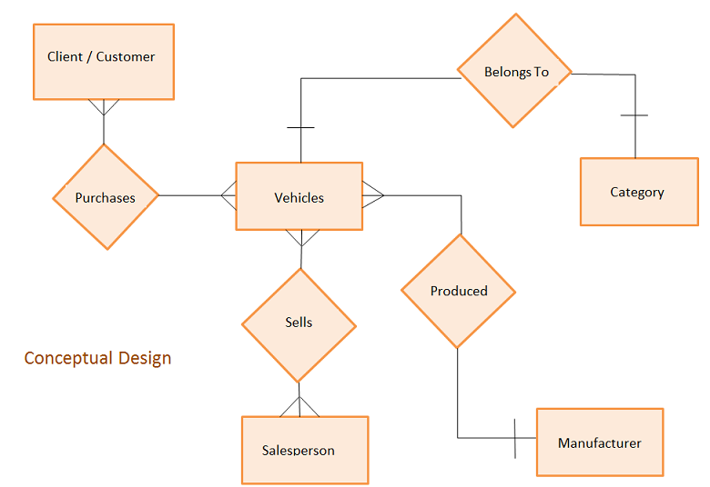

Figure Conceptual Design

Define any validation rules required – list in a table, include in the Entity diagram (Conceptual Design)

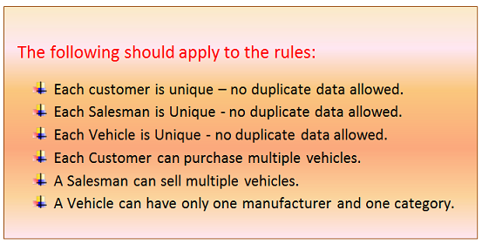

Figure Specified Validation rules

### Logical Design

* Identify primary and foreign keys in your tables (Logical Design diagram)
* List the data types and field sizes for the database tables described in the specifications

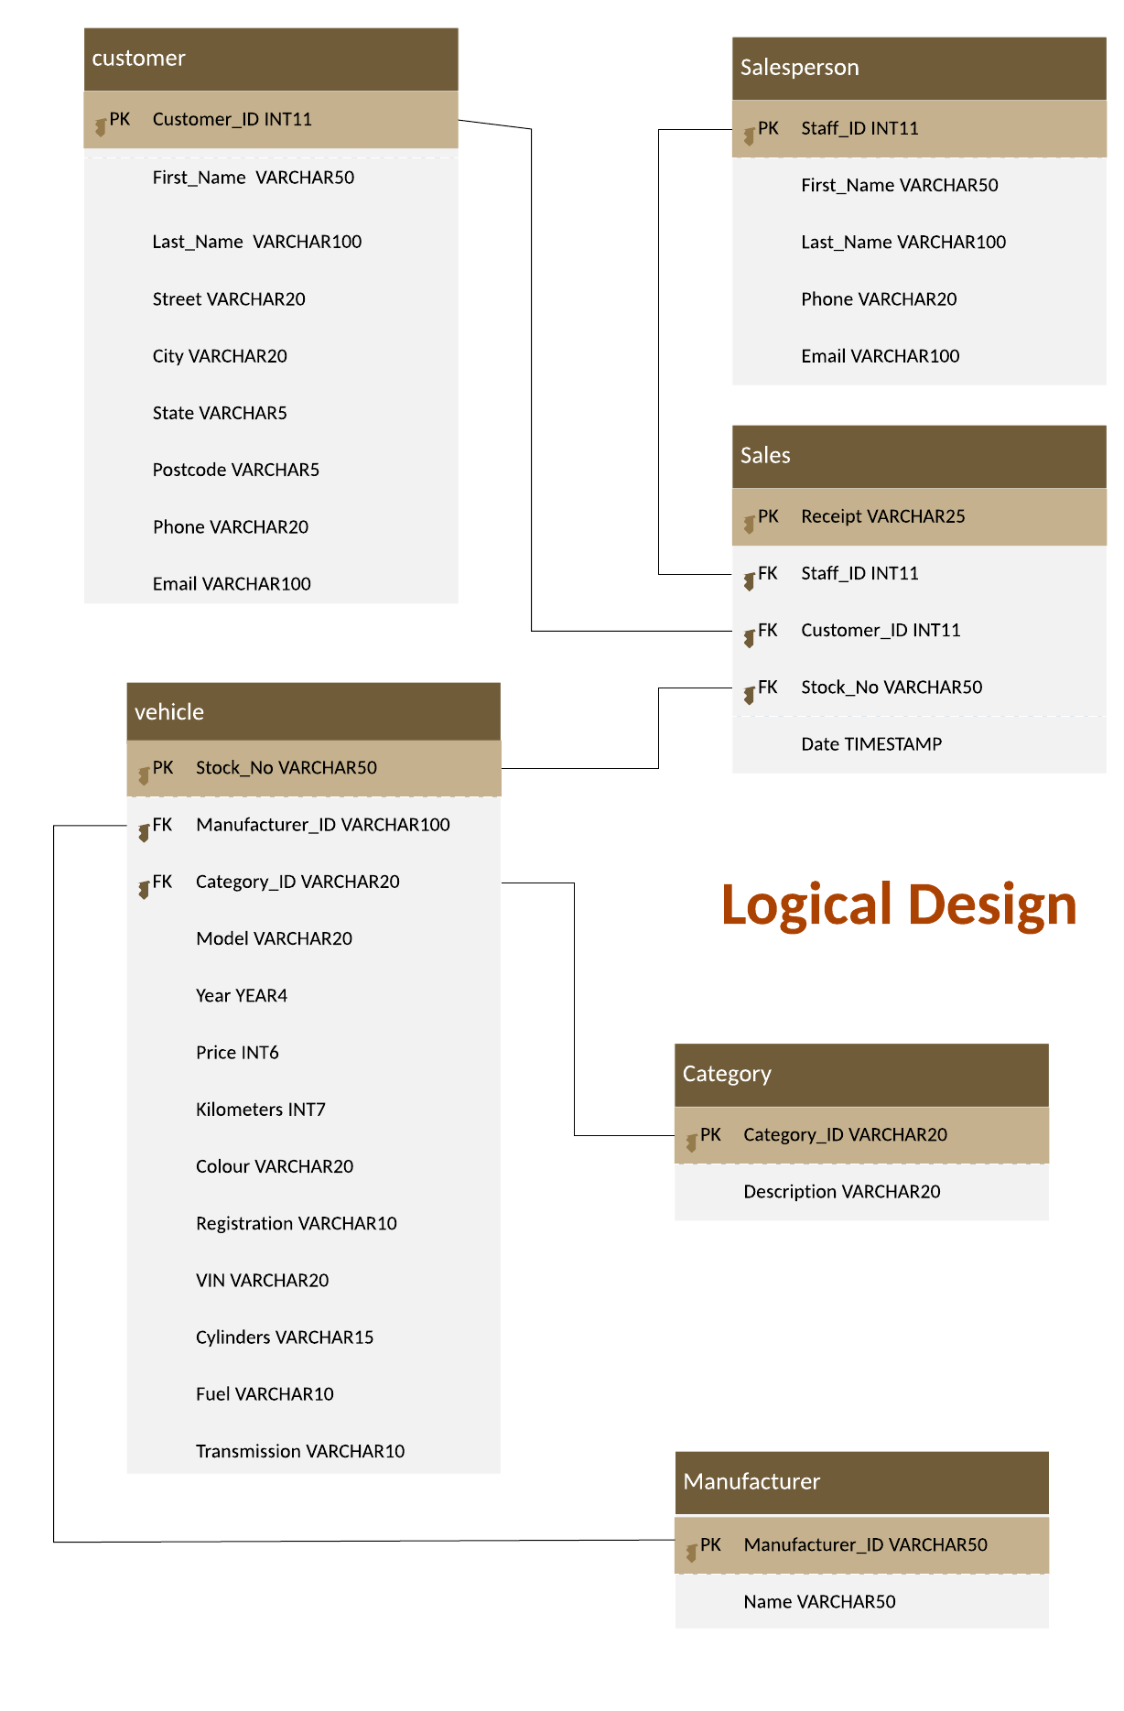

Figure Logical Design

The following rules should apply to the data:

• Each customer is unique – no duplicate data allowed

• Each salesperson is unique – no duplicate data allowed

• Each vehicle is unique – no duplicate data allowed

• A customer can purchase multiple vehicles

• A salesman can sell multiple vehicles

• A vehicle can have only one manufacturer and one category

.

### Referential integrity

For referential integrity to hold in a relational database, any field in a table that is declared a foreign key can contain a either null value, or only values from a parent table’s primary key. In other words, when a foreign key value is used it must reference a valid, existing primary key in the parent table. For example deleting a record that contains a value referred to by a foreign key in another table would break referential integrity.

Referential integrity is a guarantee that the target it refers to will be found. A lack of referential integrity in a database can lead relational databases to return incomplete data, usually with no indication of an error.

The relationship between the primary key of one table and the foreign key of another table must always be maintained. For example, a primary key cannot be deleted if there is still a foreign key that refers to this primary key.

Primary key / unique constraint

Primary keys and the UNIQUE constraint are used to make sure every row in a table can be uniquely identified.

Valid Values

Only allowed values are permitted in the database. For example, if a column can only have positive integers, a value of '-1' cannot be allowed.

### 

* Identify referential integrity constraints - list any constraints associated with the primary and foreign keys.

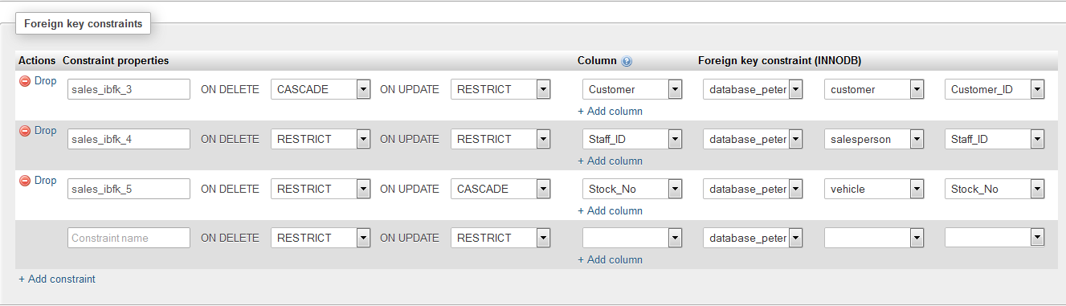

Figure Referential Constraints - Sales table

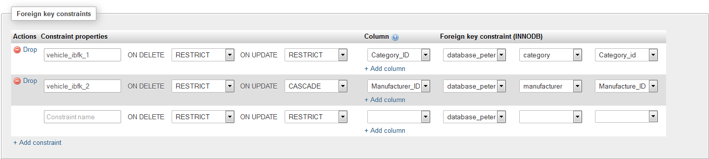

Figure Referential Constraints - Vehicle Table

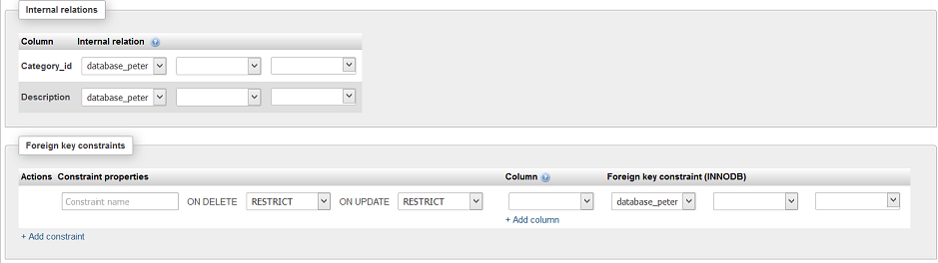

Figure Referential Constraints - Category table

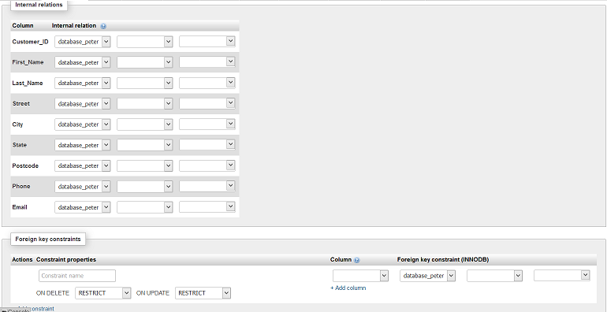

Figure Referential Constraints - Customer table

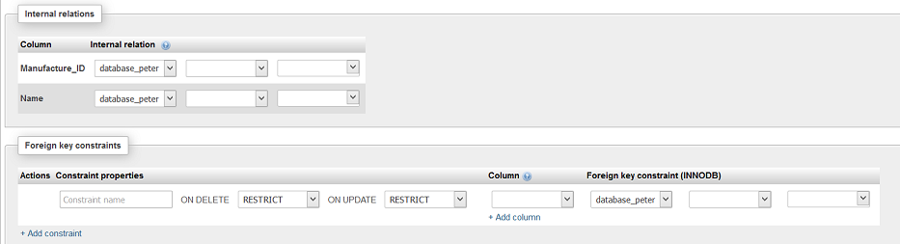

Figure Referential Constraints - Manufacturer table

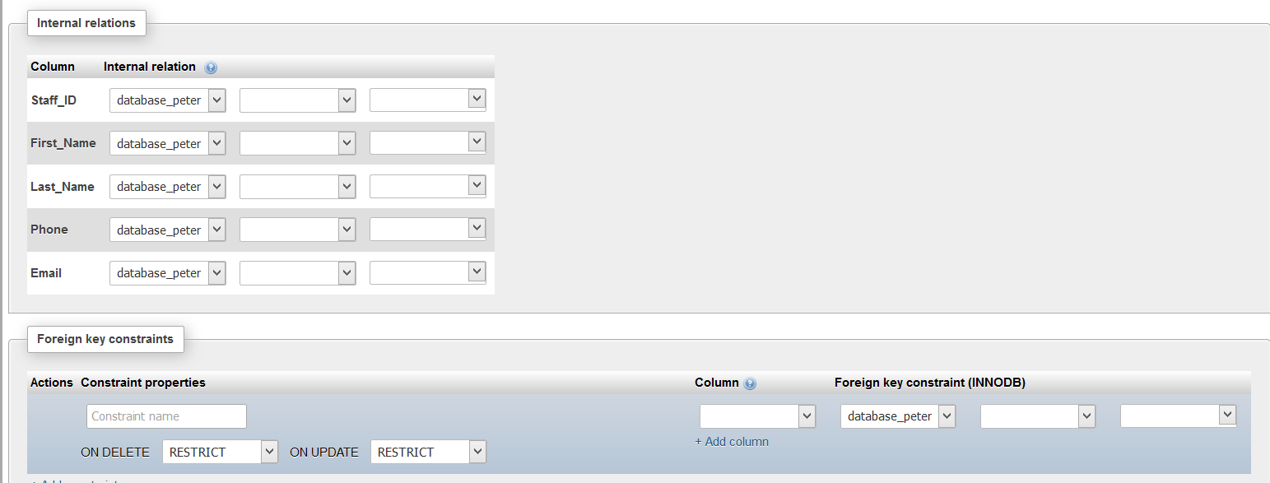

Figure Referential Constraints - Salesperson table

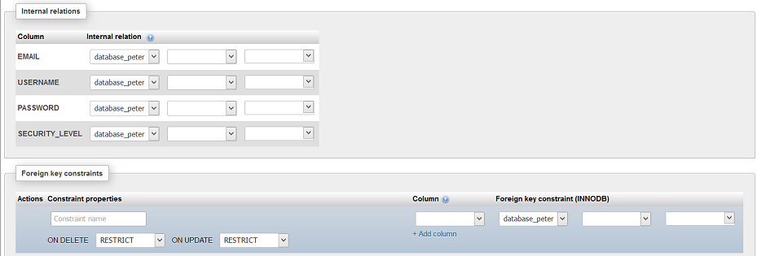

Figure Referential Constraints - Users table

Develop a data dictionary – list the data types and field sizes in a table for all tables.

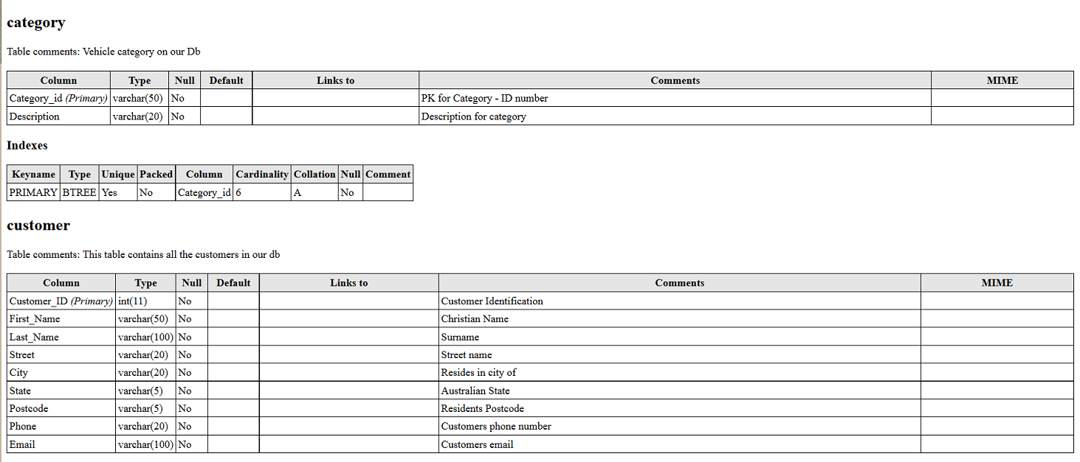

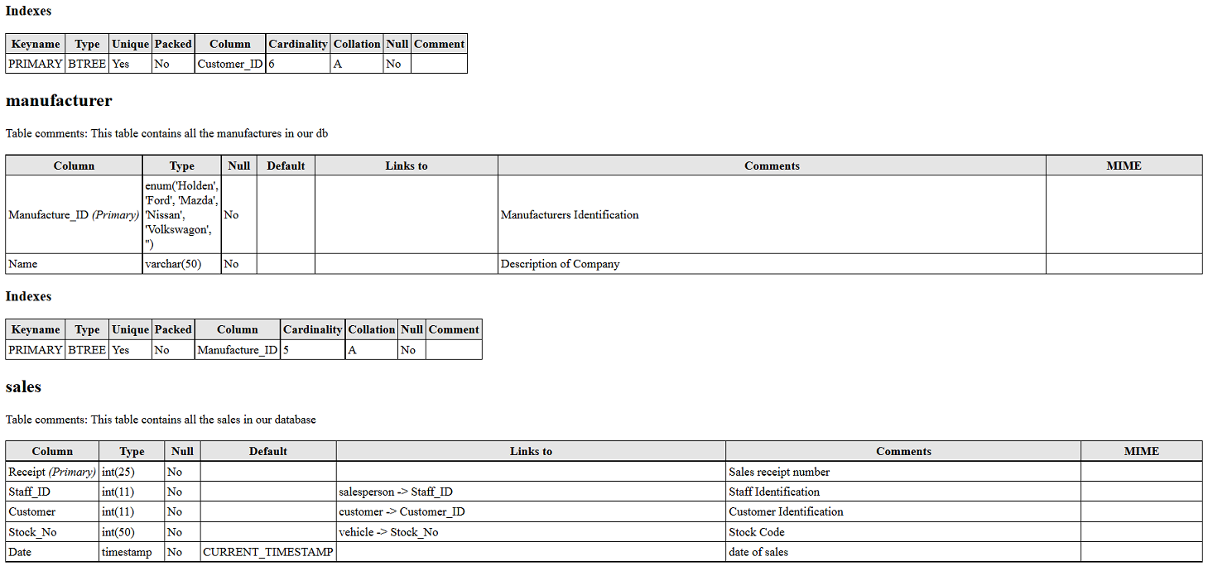

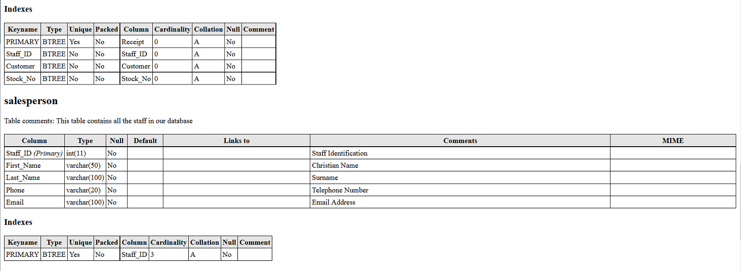

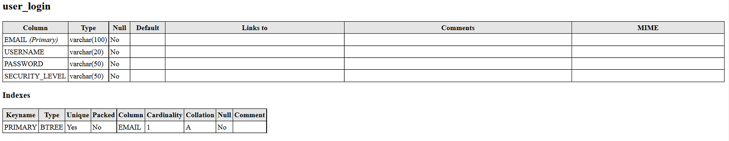

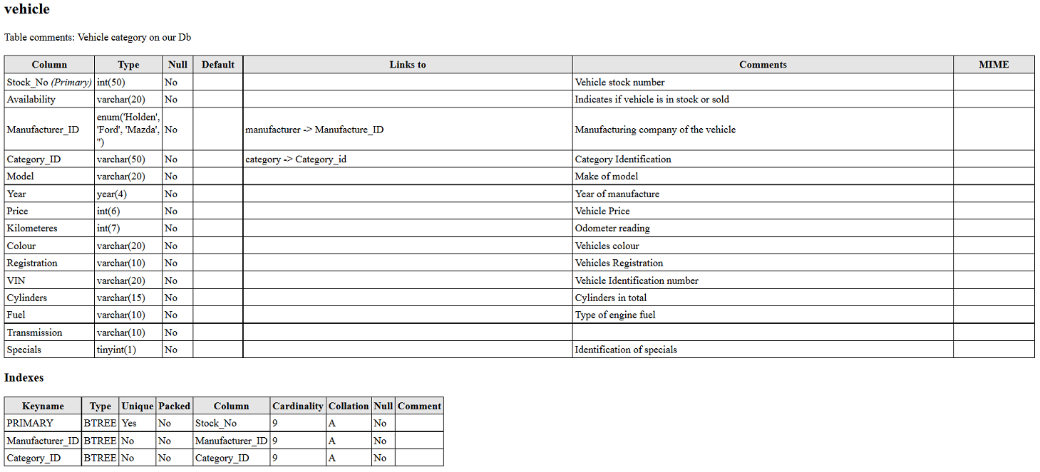

Figure Database Dictionary

## Task 2 - create database

For this task you are required to create the database in accordance with your **database requirements report**. You should:

* Using MySQL or an alternative graphical interface create a new database
* Take a screenshot showing your database in the command prompt window, phpMyAdmin or similar

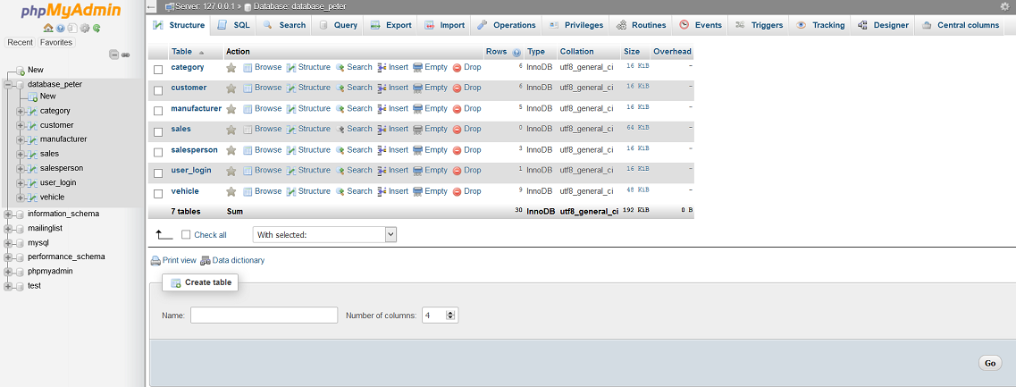

* Create tables in the database based on your requirements report
* Take a screenshot showing your database tables in the command prompt window, phpMyAdmin or similar

### Database Tables

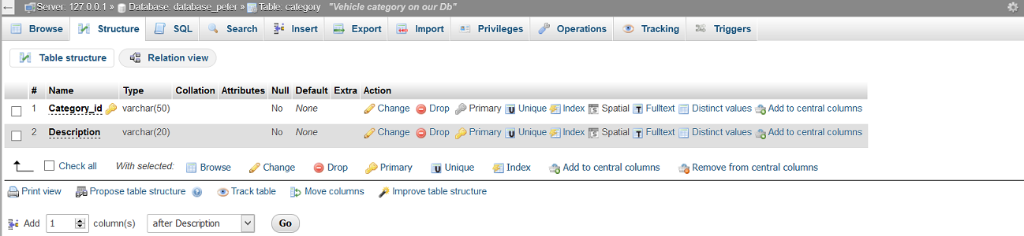

Category Table

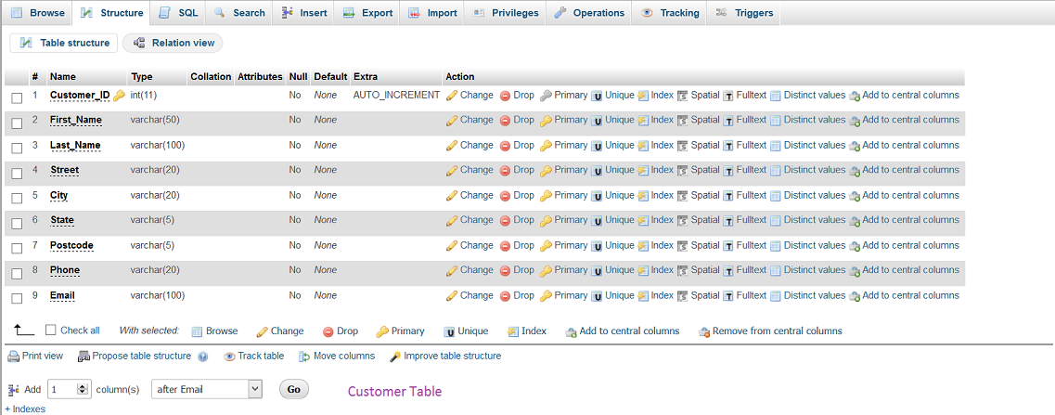

Customer Table

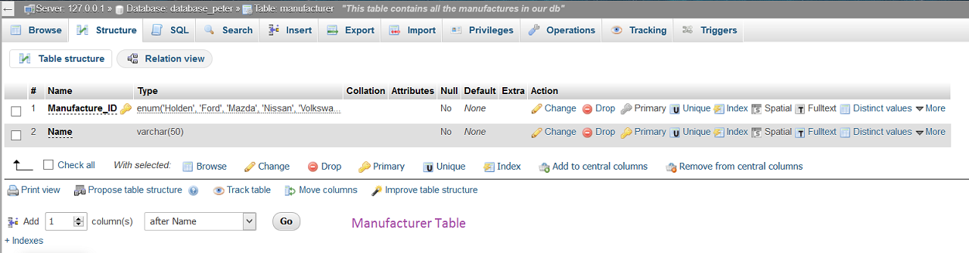

Manufacturer Table

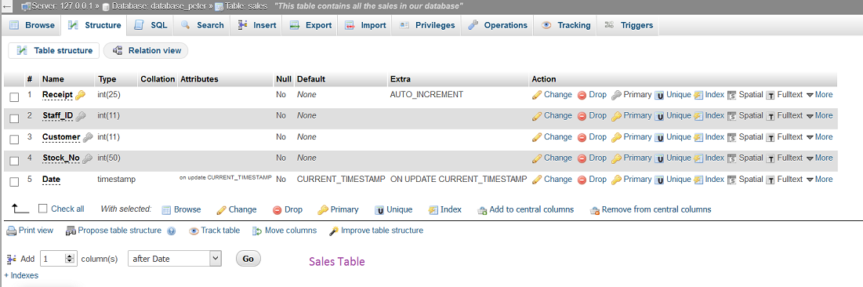

Sales Table

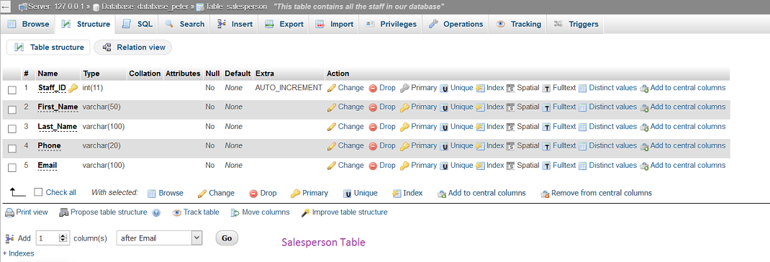

Salesperson Table

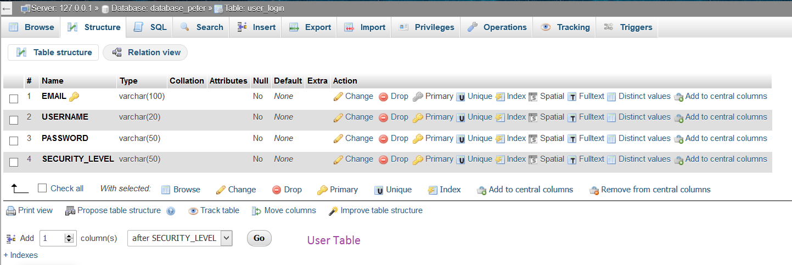

User Table

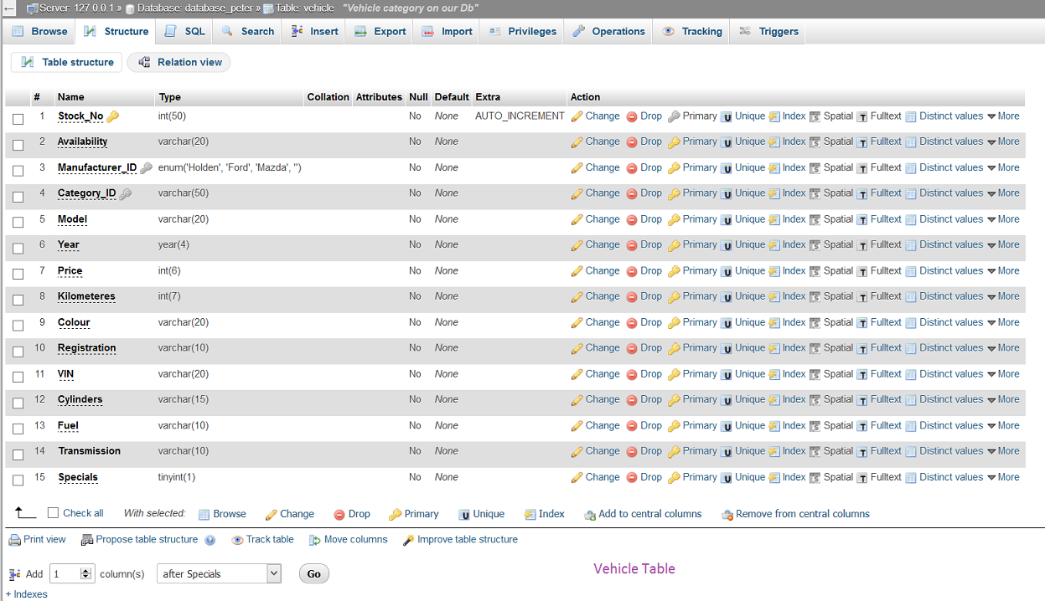

Vehicle Table

* Add some sample data to your database tables

Figure Sample data added to data tables

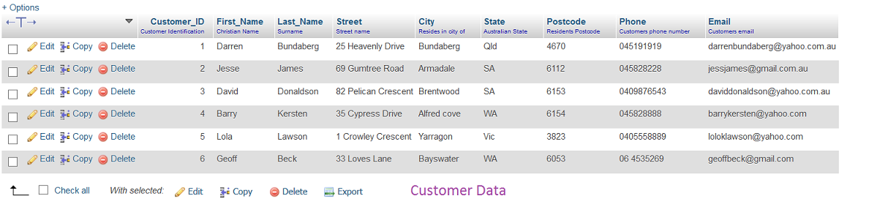

Customer Data added.

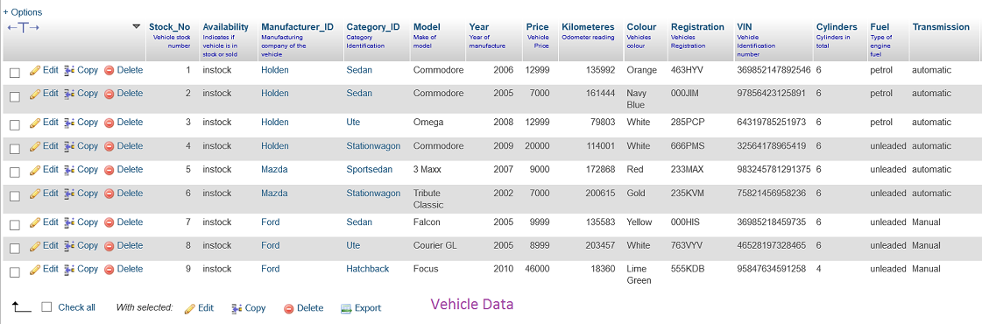

Vehicle Data added.

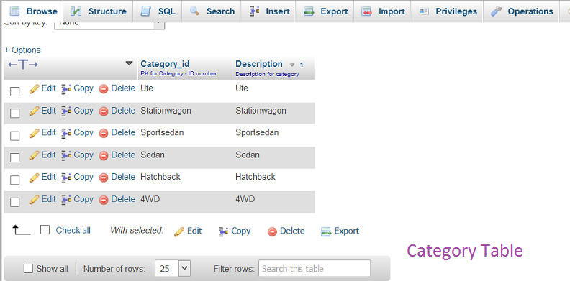

Category Data added.

* Export your database and save with an appropriate filename (eg: *database_sample.sql*)

## Task 3 - Design user interfaces

For this task you are required to design the user interfaces according to the requirements document. You should:

* Design the user interface pages according to the requirements report (Your designs can be either created in a graphics editing package such as Photoshop or a simple HTML mockup)
* Ensure designs are well laid out and include all appropriate fields and buttons.



Figure - Home Page. Interface Mock Up

Figure WCA Mission & Vision \ Interface Mock Up



Figure WCA About Page \ Interface Mockup

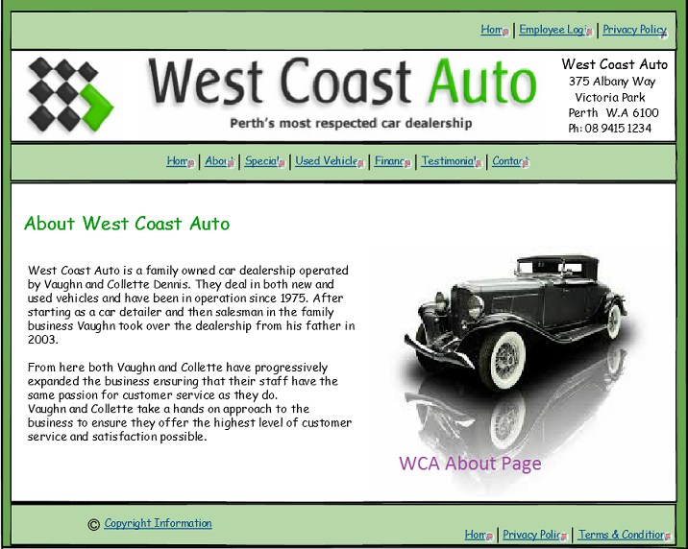



Figure WCA Specials Page \ Interface Mockup

Figure WCA Used Vehicles Page \ Interface Mockup

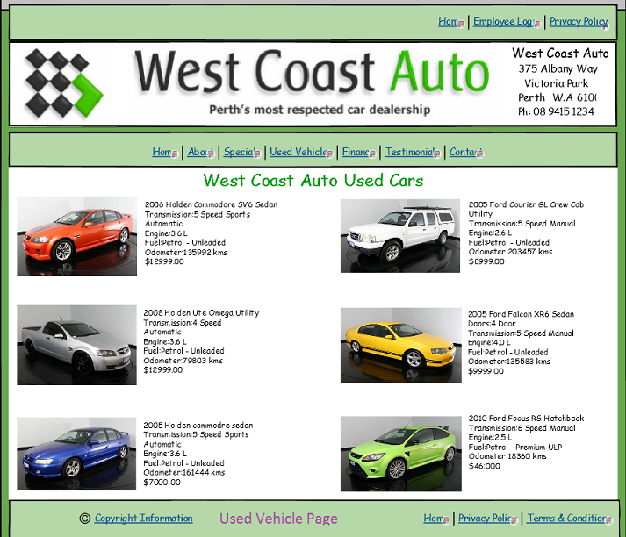



Figure WCA Testimonial \ Page Interface Mockup

Figure WCA Finance Page \ Interface Mockup

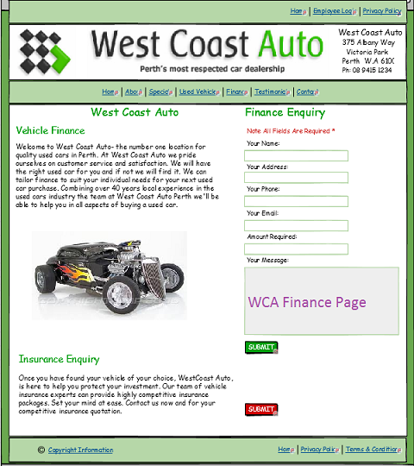

Figure WCA Privacy policy \ Interface Mockup

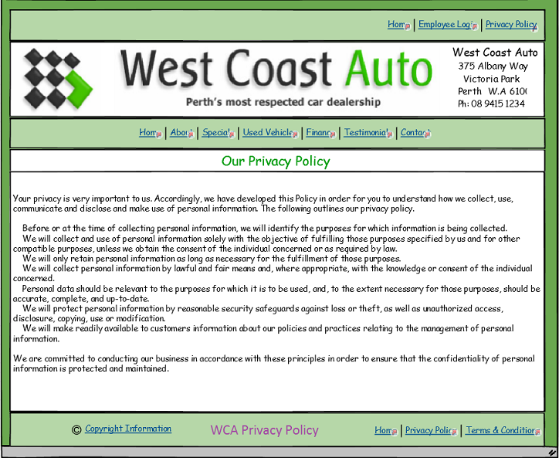

Figure WCA Contact Page \ Interface Mockup

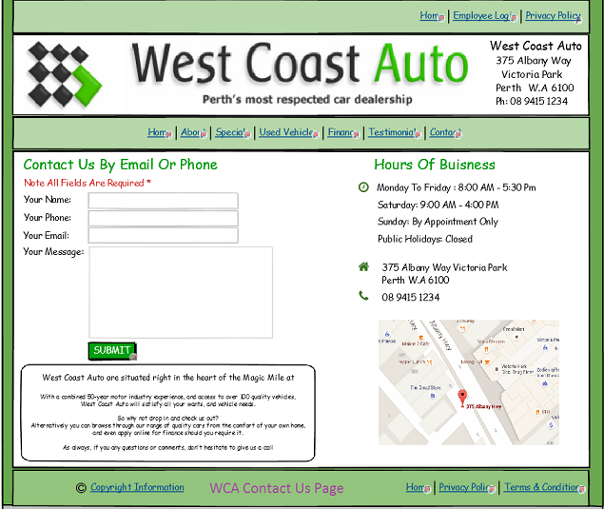

Figure WCA Vehicle Data \ Interface Mockup

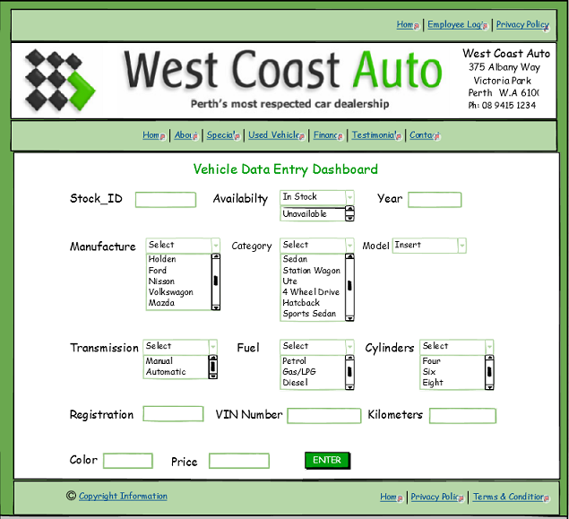

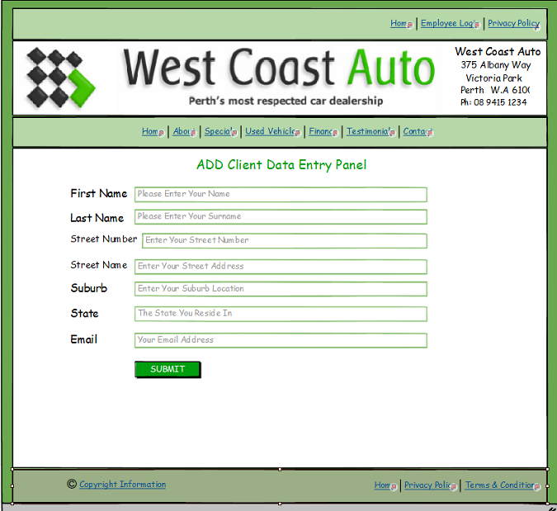

Figure WCA Client Data \ Interface Mockup

## Task 4 - Create security policy

For this task you are required to create a security policy for the database. You should:

* Create a User Privileges table based on the requirements document

Figure User Privileges

|  |  |  |  |  |  |  |  |  |
| --- | --- | --- | --- | --- | --- | --- | --- | --- |
|  | Vehicle Data |  | Customer Data | |  | Staff Data | |  |
| Guest | View |  | View |  | | View |  | |
|  | Write |  | Write |  | | Write |  | |
|  | Delete |  | Delete |  | | Delete |  | |
| Customer | View |  | View |  | | View |  | |
|  | Write |  | Write |  | | Write |  | |
|  | Delete |  | Delete |  | | Delete |  | |
| Sales / Staff | View |  | View |  | | View |  | |
|  | Write |  | Write |  | | Write |  | |
|  | Delete |  | Delete |  | | Delete |  | |
| Administrator | View |  | View |  | | View |  | |
|  | Write |  | Write |  | | Write |  | |
|  | Delete |  | Delete |  | | Delete |  | |
|  |  |  |  |  | |  |  | |
| Denotes |  | Yes |  | No | |  | Limited | |

Administrators have full permission and access control of the Database, where they can View, Write, and Delete any information required to maintain the Database.

### Develop a naming convention for login names

* Staff_id - automatically generated by the database.
* Usernames - FirstName_LastName
* All Lowercase – no special characters.
* Only Alphabetical Letters and Underscore to be used.

This way we avoid duplicates and maintain the logic behind the creation of login names.

* Create a password policy for users

## West Coast Autos Password policy

In an effort to provide a more secure computing environment, West Coast Autos has implemented a password security policy for staff and Users. The following is a brief description of the password policy requirements.

* Enforce password history - 5 passwords remembered.
* Maximum password age - 180 days.
* Minimum password age - 1 day.
* Minimum password length - 8 characters.

Strong passwords are required and must meet the following minimum requirements:

* Not contain all or part of the user's account name.
* Be at least eight characters in length.
* Contain characters from three of the following four categories:
  + English uppercase characters (A through Z)
  + English lowercase characters (a through z)
  + Base 10 digits (0 through 9)
  + Non-alphabetic characters (Only these are allowed: ! % * + , - / : ? _ ).

An example of a complex password is J*p2leO4-F.  
The simplest way to create a valid complex password is to include at least 1 lowercase letter, at least 1 uppercase letter, and at least 1 number. The password must contain at least 8 characters.

**Account Lockout Policy**

* Account lockout after (5) five failed login attempts.
* Account lockout duration 15 minutes.
* Account reactivated after 15 minutes

**Best practices for account protection**

* Never share passwords with anyone.
* Never allow others to use your account for any reason.
* Change your password immediately if you think it has been compromised.
* If passwords must be written down on a piece of paper, store the paper in a secure place and destroy it when it is no longer needed. Treat your password like you would your personal credit card.
* Be careful where passwords are saved on computers. Some dialog boxes, such as those for remote access and other telephone connections present an option to save or remember a password. Selecting this option poses a potential security threat.

## Task 5 - Create backup procedure

For this task you are required to create a backup procedure for the database. You should:

* Define a suitable schedule for backup of the database
* Define where and how the backup should be stored

You will need a backup copy of your database to either restore the whole database if there is a system failure or to restore an object when the **Undo** command merely isn't enough to fix a mistake.

If a backup copy of your database seems a wasted use of storage space, consider the time that you might save by avoiding data and design loss. Creating backups on a regular basis is important when you have several users updating your database. Without a backup copy, you cannot restore corrupted or missing objects or any changes to the database design.

Backup Policy to be implemented:

* Backup performed of the database to be done manually using PHPMyAdmin export facility and saved to USB drive, external hard drive or the Cloud.
* All backups to be saved as “Data_Backup_(date).sql
* Incremental backups to be carried out twice a week.
* A full back up to be done at the end of every week.
* At the end of every month all backups for that month will be stored offsite at west Coast Autos managers residence as well as a copy stored to the cloud, such as Google drive, Zip cloud or even Github.